

School of Electronic Engineering and Computer Science

FINAL YEAR PROJECT REPORT

Project Title
Multi-Agent System with Emergent Behaviour

Program of Study
Computer Science

Supervisor
Edon Kelmendi

Student Name
Adam Ornoch

Abstract
This project investigates how complex global behaviours can emerge from simple local interactions in a decentralised multi-agent system. A simulation framework will be designed and implemented with autonomous agents. This project will focus on selected scenarios and situations to explore rule set and parameter influence on emergent behaviour.
Through experimentation, the system will run trials, and global patterns will be spotted through visual modelling or analytical data.

TABLE OF CONTENTS

Chapter 1: Introduction
1.1 Background
1.2 Problem Statement
1.3 Aim
1.4 Objectives
1.5 Research Questions
1.6 Report Format
Chapter 2: Literature Review
Chapter 3: Analysis & Design
3.1 Requirements Analysis
3.2 Software Development Life Cyle
3.3 Risk Register
Chapter 4: Implementation
Chapter 5: Extra
5.1 References
5.2 Project Plan
5.3 Supervisor Presentation Notes
5.4 Presentation Slides

Introduction

Background
Multi-agent systems (MAS) are computational systems composed of multiple autonomous entities that interact locally with each other and their environment. Research in this region shows numerous instances of unpredictable patterns arising from local interactions of individual components within a system (Emergent Behaviour). A key component of emergent behaviour is that it arises without a centralised controller. Many instances of emergence behaviour have been discovered and studied in both natural and artificial systems, such as for example how ant colonies form bridges to traverse between gaps in their environment. Existing literature highlights the importance of simulation-based experimentation as a method for analysing the impact of local rules and parameter changes on the emergent behaviour outcome.

Problem Statement
Emergent behaviour is an important and sometimes unpredictable concept in complex systems. Understanding how simple local interactions, lead to complex global patterns remains a challenge for many situations due to the large number of variables that must be considered.
Existing research demonstrates that selecting influential agent rules and implementing them into a simulation can replicate or even create emergent behaviours. Small variations in parameters can result in substantially different outcomes. This project addresses the problem of providing a configurable and observable simulation environment that allows for exploring, understanding and replicating emergent behaviours in multi-agent systems.

  - Aim
The aim of this project is to design and develop a multi-agent simulation system to investigate how global patterns emerge from local interactions between autonomous agents. The system will operate without a centralised control, with agents acting independently according to a defined set of behavioural and interaction rules.
The project further aims to analyse how variations in agent rules and system parameters influence the emergence of collective behaviours through mass
simulations.

Objectives

- Conduct background research
- Gather information about existing models.
- Identify existing agent rulesets, simulation design choices, and methods through which analytics are gathered.
- Identify how to spot emergent behaviours.

- Plan the system
- Construct class diagrams.
- Identify language and libraries to be used.
- Illustrate the system structure (agents, simulation environment).

- Build a baseline simulation framework
- At this stage, the system should allow agent creation & interaction as well as the ability to run simulations with adjustable parameters.
- Display basic analytics.

- Implement a model to simulate
- Add specific agent rules and behaviours with other agents and the environment.
- Tune parameters.
- Observe for emergent behaviours.

- Analyse observed emergent behaviour
- Iteratively improve the simulations accuracy by adjusting and improving agent behaviour and interactions.
- C0mpare results against studies.

- Implement further simulation models
- Design custom simulations and implement them.
- Test simulations and record emergent behaviours.

- Evaluate the system

Research Questions

- How do simple local interaction rules between agents lead to the emergence of global behavioural patterns?

- What impact does tuning parameters in the simulation have on the emergent behaviour?

- What impact do specific agent rules have on the emergent behaviour?

- To what extent can emergent behaviours be accurately recreated though a computational simulation system?

Report Format
- Chapter 1 – Introduction
  - Introduce the project context.

- Chapter 2 – Literature Review
  - Review existing research on multi-agent systems and emergent behaviour.

- Chapter 3 – Analysis & Design
  - Describe overall architecture and justify design choices.

- Chapter 4 – Implementation
  - Describe the software used to develop the system

- Chapter 5 – Extra
  - Stores references & the project plan

Literature Review

Flocks, Herds and Schools: A Distributed Behavioural Model – Craig W. Reynolds
Overview:
Reynold proposed a distributed behavioural model to demonstrate how realistic bird flocking behaviour can emerge from local interactions between autonomous agents. The aim was to produce an animation of a flock of bird through giving each bird local rules that dictate its behaviour and interaction with other boids (bird objects).
Approach:
Reynolds aimed to create this animation without using a centralised control system and not manually assigning a flight path to each boid. Each agent, referred to as a “boid”, is an independent entity that follows three simple behavioural rules:
- Collision avoidance: avoid collisions with nearby boids.
- Velocity matching: attempt to match velocity with nearby boids.
- Flock Centering: attempt to stay close to nearby boids
Combining these rules, as well as giving the boids a local perception of other nearby boids, gives rise to the emergent behaviour: flocking.
Key Findings:
This study shows that complex collective motion can emerge reliably from decentralised systems with autonomous agents interacting with one another. Changes in parameter values will result in different variations in the flock-like collective behaviour.
Strengths:
The paper clearly demonstrates that emergent behaviour does not require complex agents or central control. The rule simplicity makes the model easy to implement and extend. Models like this one can have real life applications where an animator wishes to display birds (or other animals in a group), without manually hardcoding each animal’s pathing.

Limitations:
It is difficult to objectively measure the accuracy of these flock simulations compared to real bird flocking behaviour. The model also doesn’t cover scalability issues as well as managing a larger group of agents with more complex rules.
Relevance to this Project:
This research provides a baseline simulation to test and compare the resulting global patterns formed from simulating with autonomous agents. It validates the use of decentralised, rule-based agents to study emergent behaviours.

Emergent behaviours in multi-agent systems with Evolutionary Game Theory – T.A. Han
Overview:
This study investigates how emergent behaviours arise in multi-agent systems through the application of Evolutionary Game Theory (EGT). The underlying question of understanding the mechanisms governing cooperative behaviour is explored. The study focuses on analysing patterns in agents’ strategies and how they evolve, including: recognition, commitment, trust and guilt. Through agent interactions, agents learn and adapt their strategy to aim towards the best outcome.
Approach:
Agents are modelled as players in repeated games, where each agent selects strategies and receives payoffs based on interactions with neighbouring agents. Agents have 4 key emotional / cognitive capabilities:
- Intention recognition – Ability to read intentions of others.
- Commitment – Giving up options to influence others, some commitments depend on an incentive that ensures a payoff in the future.
- Trust – Trust can be used as a cognitive shortcut to reduce the complexity of interactions. This is a mechanism that influences future payoffs and functions if the other player is observed to be cooperative.
- Guilt – Guilt is modelled as a record of transgressions and a threshold over which the guilty agent must alleviate the associated emotional pain.
Key Findings:
The study manages to demonstrate stable emergent behaviours such as cooperation or dominance of certain strategies. The study translates real world factors into computed rules and parameters. Counterintuitive conclusions arise such as: through promoting positive behaviour, it can lead to agents exploiting cooperators.
Strengths:
The integration of Evolutionary Game Theory into multi-agent systems allows agents behaviour to evolve rather than remain static. It explores long-term behavioural trends which are quite realistic as agents get to repeat interactions and change their strategies.
Limitations:
Simple game structures might not fully capture the complexity of real-world behaviour. Important variables with significant impacts can be overseen because of the complexity of a human interaction.
Relevance to this Project:
Han’s study adds an interesting idea of EGT, where adaptive strategies can be explored instead of fixed agent rules. Han’s study gives an insight of breaking down real world factors that affect interactions and turning them into computational rules with parameters.

Emergent behaviours and scalability for multi-agent reinforcement learning-based pedestrian models – Martinez-Gil et al.
Overview:
This study analyses emergent behaviour of pedestrian groups that learn through multi-agent reinforcement learning. A crowd is created from autonomous agents which follow pathing and collision-avoidant behavioural rules.
Approach:
Agents are modelled as pedestrians that learn movement behaviours using reinforcement learning techniques based on reward systems to avoid collisions, achieve their goal and achieve it with efficiency. Different population sizes are tested with different crowd scenarios. Each agent is aware of agents in their proximity. Some scenarios include:
- Quickest path vs shortest path – Agents choose between two exits at different distances. The exit nearer to the agents is crowded.
- Two opposing groups in front of a door – Two groups of pedestrians try to get to the other side of the door. The door is narrow and only fits one person passing at a time.
- Free field – Each pedestrian must travel to a random destination in a crowded environment.
Key Findings:
This study demonstrates realistic pedestrian patterns emerging from decentralised autonomous agents. The findings also point towards performance and stability degrading as the number of agents increases, highlighting scalability as a challenge.
Strengths:
The ability to generate realistic emergent behaviours through learning rather than from predefined rules.
Limitations:
The reliance on reinforcement learning introduces high computational costs and long training times as agent populations increase. On top of that, there is no objective way to interpret emergent behaviours in these crowd scenarios, potentially exposing the study to bias and invalid findings.
Relevance to this Project:
The study implements autonomous agents with reinforcement learning-based rule sets. It uses a visual display of agents traversing the environment, allowing for visual analysis.

Analysis & Design

3.1 Requirements Analysis

Functional Requirements:
- The system will simulate multiple autonomous agents that can interact with each other.
- Each agent will follow a set of local rules.
- Emergent behaviours can be deduced through analytics or 2D/3D modelling as they arise.
- The system will have adjustable parameters for the simulations.
Non-Functional Requirements:
- The system should handle simulations with 100 agents.
- The framework should allow for additional agent rules to be added.

3.2 Software Development Life Cycle

I have chosen an iterative SDLC for this project due to the exploratory nature of emergent behaviour. System behaviour cannot be predicted in advance, therefore the project must be developed and improved through successive iterations, refining agent rules and observing outcomes.
This approach reduces development risk that a linear development model might have. This would include assuming requirements which may end up being incorrect, resulting in the system not being developed in the correct direction.

Below I have illustrated an iterative design process that I will follow:
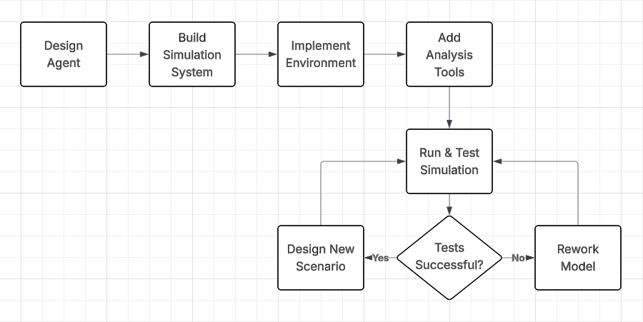

3.3 Risk Register
Risk Description | Likelihood | Impact | Risk Level | Mitigation Strategy
Emergent behaviour deviates from intended outcome | High | Medium | High | Define constraints on agent rules, test with small population first
Performance degrades with increasing agent numbers | Medium | High | High | Limit agent count, optimise code complexity
Emergent behaviour fails to appear | Medium | Medium | Medium | Introduce adaptive parameters or mutations
Simulation results are difficult to validate or explain | Medium | Medium | Medium | Define measurable metrics, collect statistical data, re-run simulations
Scaling emergent behaviours fails | Medium | High | High | Incrementally scale agent count and validate findings at each stage
Project scope becomes too large due to complex agent interactions | Medium | Medium | Medium | Clearly define system boundaries and emergent goals early

Extra

5.1 References

- Reynolds, Craig W. (1987) Flocks, Herds, Schools: A Distributed Behavioral Model. Available at: https://dl.acm.org/doi/pdf/10.1145/37402.37406

- Han, T.A (2022) Emergent behaviours in multi-agent systems with Evolutionary Game Theory. Available at: https://journals.sagepub.com/doi/full/10.3233/AIC-220104

- Martinez-Gil, Francisco et al. (2017) Emergent behaviors and scalability for multi-agent reinforcement learning-based pedestrian models. Available at: https://www.sciencedirect.com/science/article/pii/S1569190X17300503

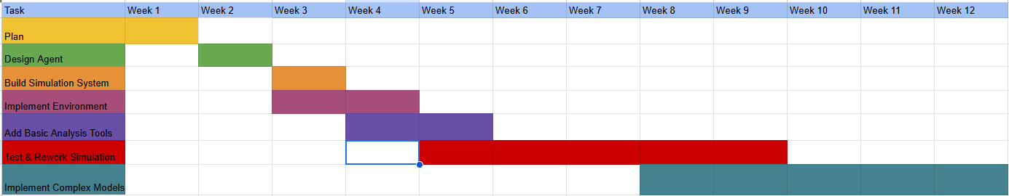
5.2 Project Plan

5.3 Supervisor Presentation Notes
- Focus on the project system over focusing on an individual simulation, showing that this project can do many things, delve into many branches, have many uses.

- Link the project to Game Development or Computer Graphics as these are modules I have completed. I can achieve this by designing simulations that explore these areas.

5.4 Presentation Slides
